Computer Networks

Lab Task #8

Saad Ahmad

20P-0051

Task#1

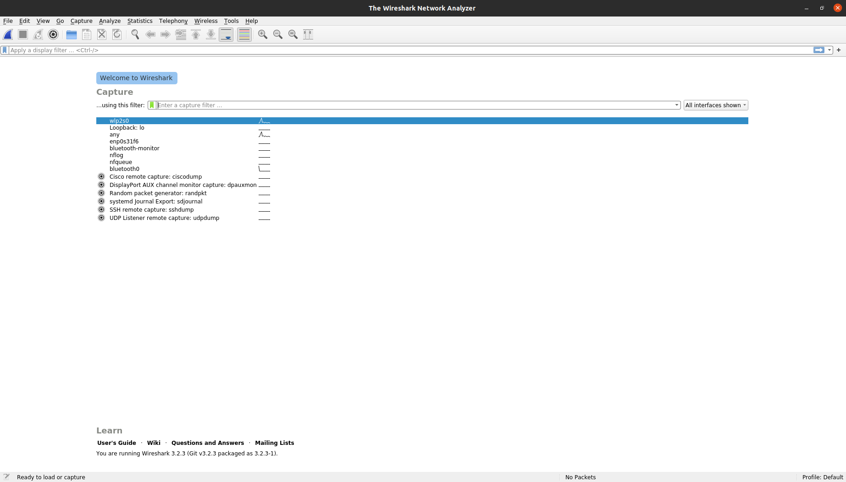Open Wireshark

Then select you **wlp2s0**

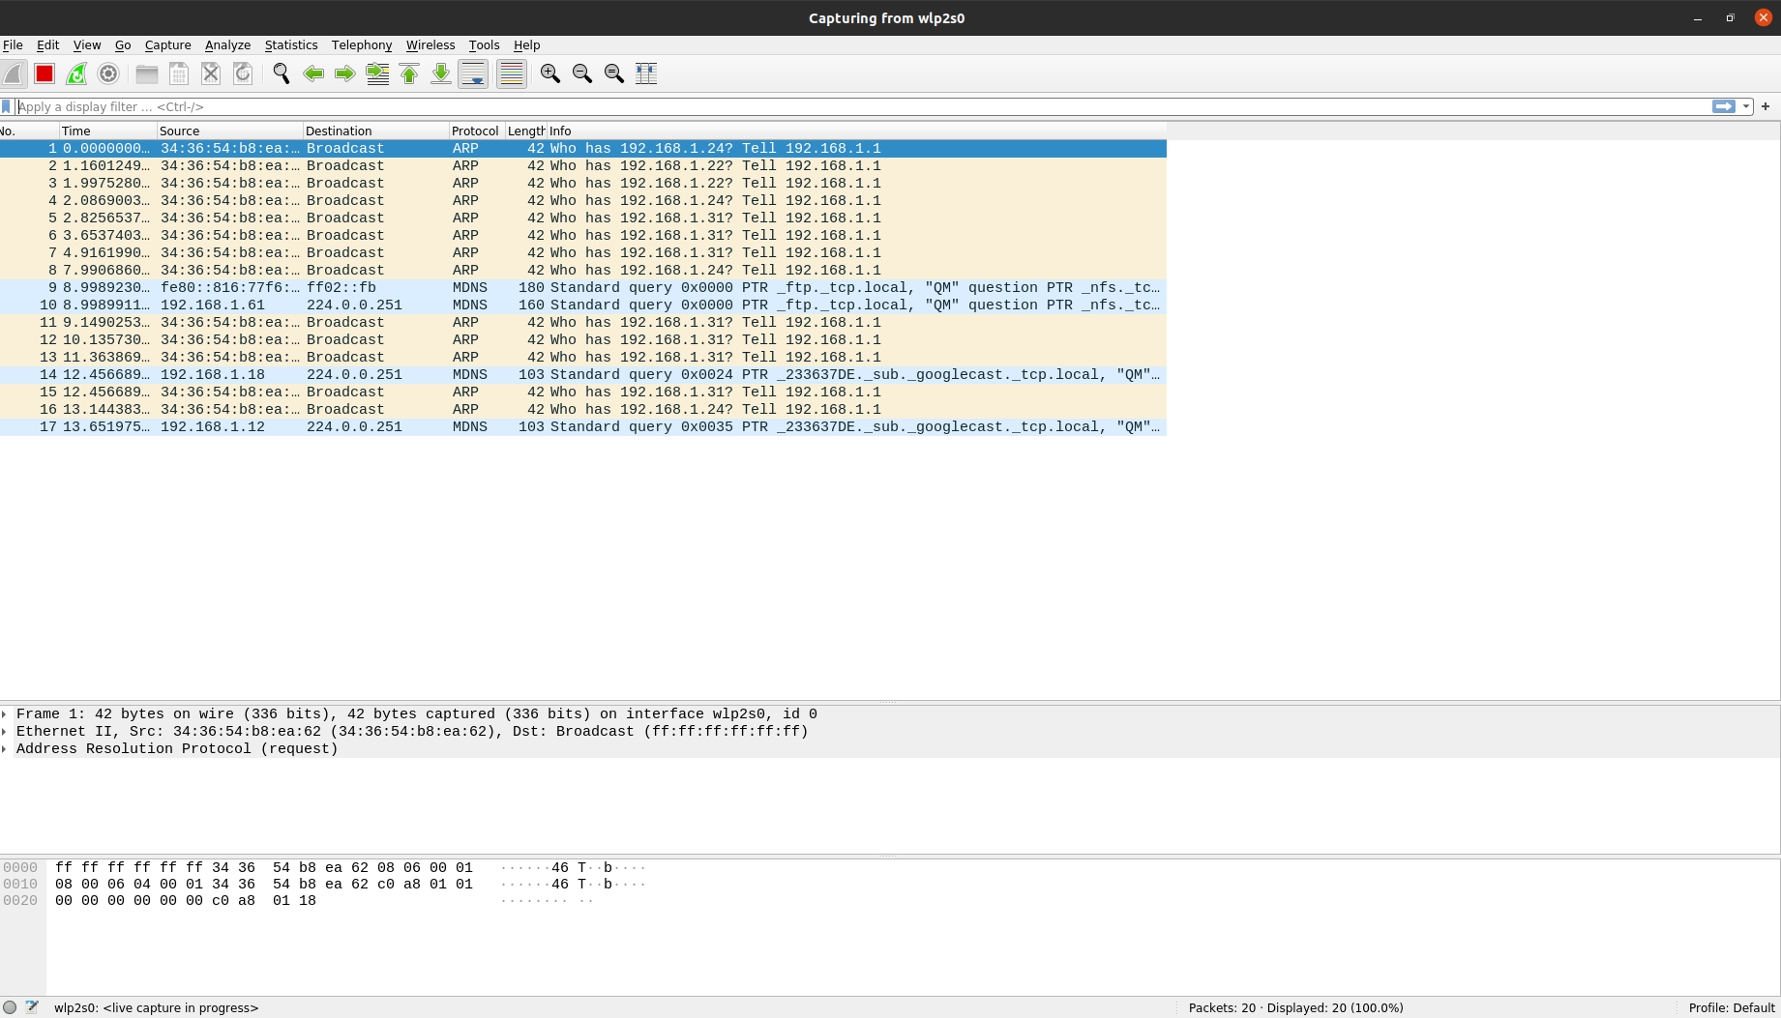

Now type the **http** in the filter bar.

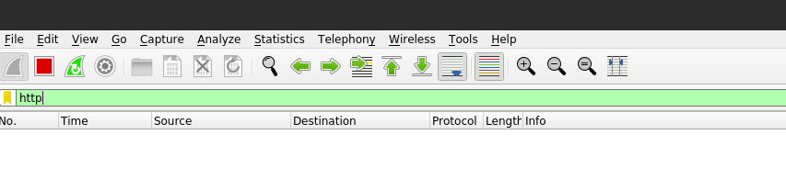

Now go to your browser and clear its cache and run the following address in the new tab

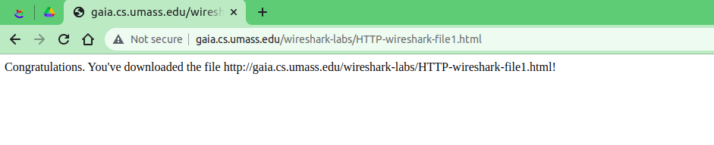 http://gaia.cs.umass.edu/wireshark-labs/HTTP-wireshark-file1.html

Now open the Wireshark again and stop capturing packets

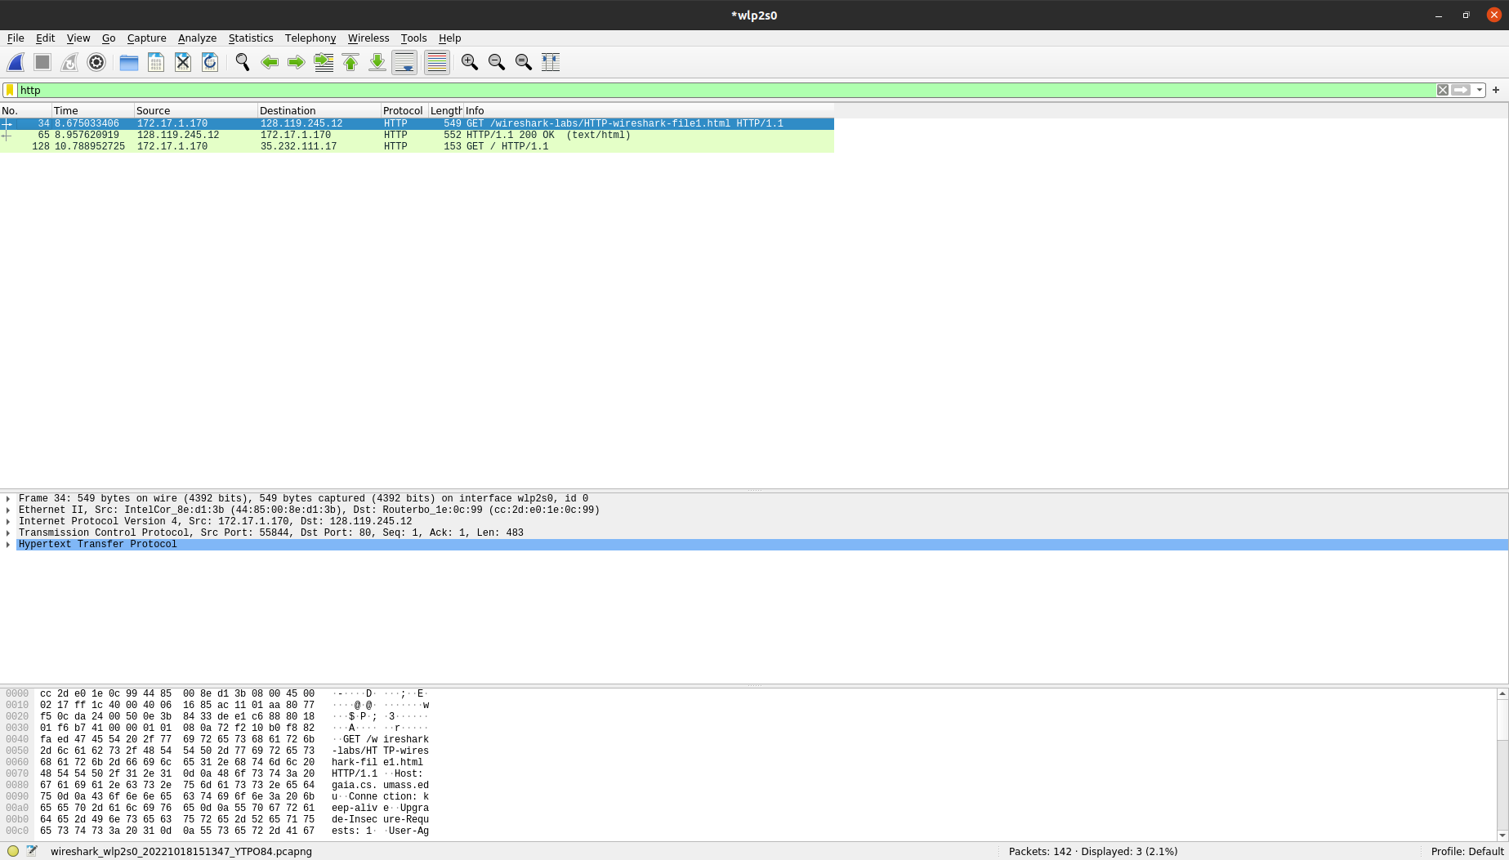

**Questions & Answers:**

1. My browser is running http version 1.1



2. Server is running http version 1.1

3. My language is en-US.



4. IP address of my computer is **172.17.1.170** and IP address of gaia.cs.umass.edu server is **128.119.245.12**



5. Status code is 200 OK

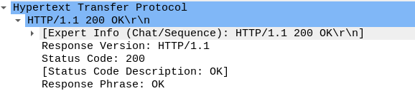

6. Last-modified: Tue, 18 Oct 2022 05:59:01 GMT

7. Content-length: 128 bytes



8. No

Task#2

Start up the Wireshark

then select you **wlp2s0** and then type the **http** in the filter bar.



Start up your web browser, and clear your browser’s cache and run the following address in the new tab

<http://gaia.cs.umass.edu/wireshark-labs/HTTP-wireshark-file2.html>

it will display some lines

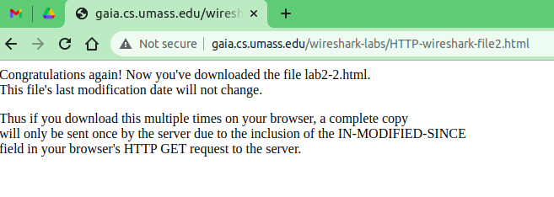Quickly enter the same URL into your browser again

Stop Wireshark packet capture.

**Questions & Answers:**

1. No I don’t see an “IF-MODIFIED-SINCE” line in the HTTP GET.

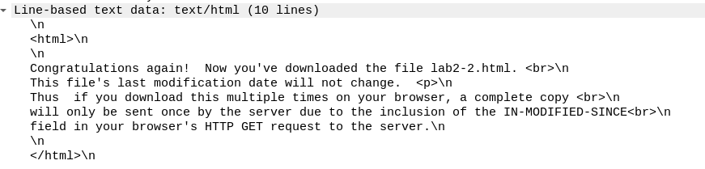2. Yes, the server explicitly returns the contents of the file as we can find it in the line-based text data

3.Yes, we see an “IF-MODIFIED-SINCE:” line in the HTTP GET

If-Modified-Since: Tue, 18 Oct 2022 05:59:01 GMT\r\n



4. the HTTP status code and phrase returned from the server in response is

HTTP/1.1 304 Not Modified

No, the server explicitly didn’t return the contents of the file it was return from the cache.

